**Project Title:** Changing Folder Permission in Windows

**Objectives:**

* This project is to understand how to create a folder in windows
* This project is to learn how to create a user in windows using GUI
* This project is to learn how to change a folder’s permission for a user

**Methodology:**

Step 1: First I am creating a folder in windows with name ‘My Folder’ by Right clicking on the open area and selecting ‘new’ then selecting ‘folder’ option.

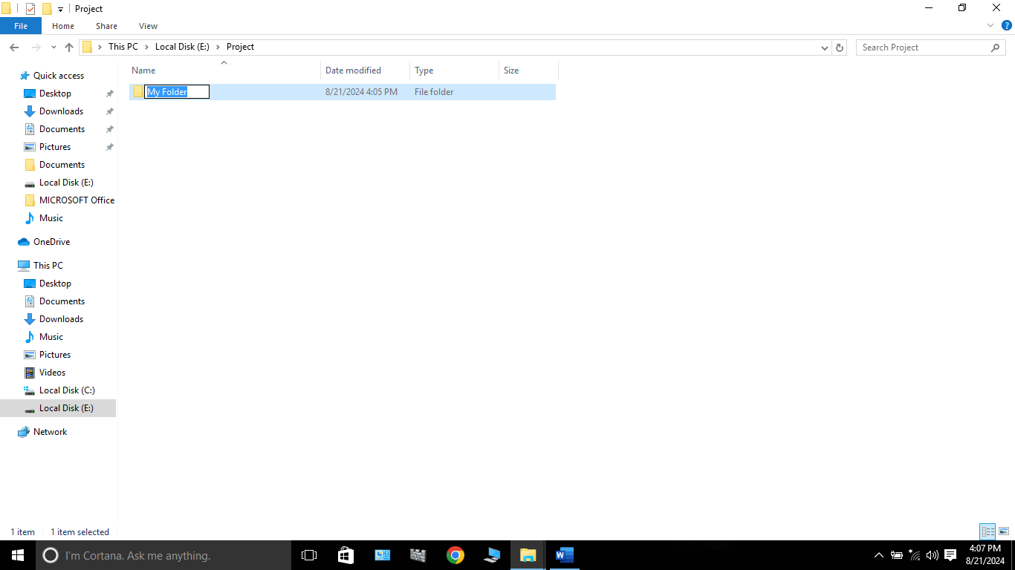

Step 2: Next I am creating a user with name ‘Test’ by going to the ‘Computer management’ -> Local Users & Groups -> Users -> More Action -> New user -> Put a User name ‘Test’ & Password and then clicking on ‘create’. Now a user called ‘Test’ is created.

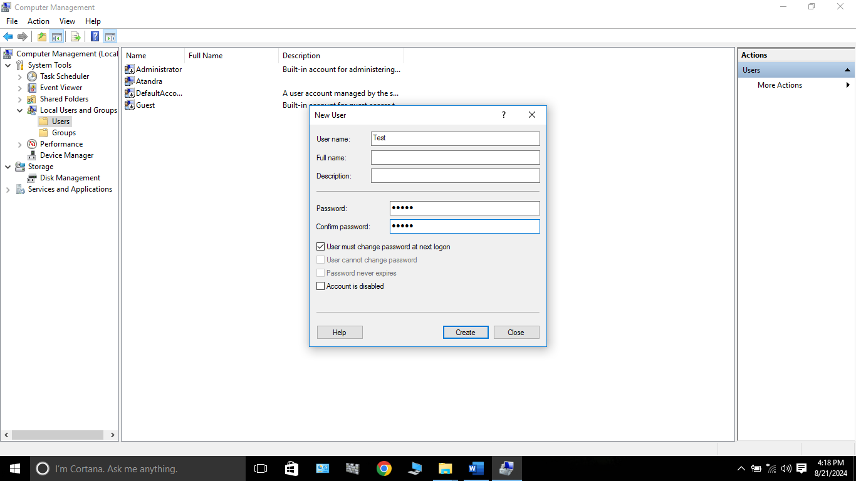

Step 3: Next I have to Right click on the ‘My folder’ and select ‘properties’ and go to ‘Security’ tab. Now I am adding the new user ‘Test’ in the list here by clicking on Edit -> Add and then typing the name of the user ‘Test’ in the ‘object names’ box and selecting ‘check names’ and selecting ‘ok’. Now ‘Test’ user is displaying in the list.

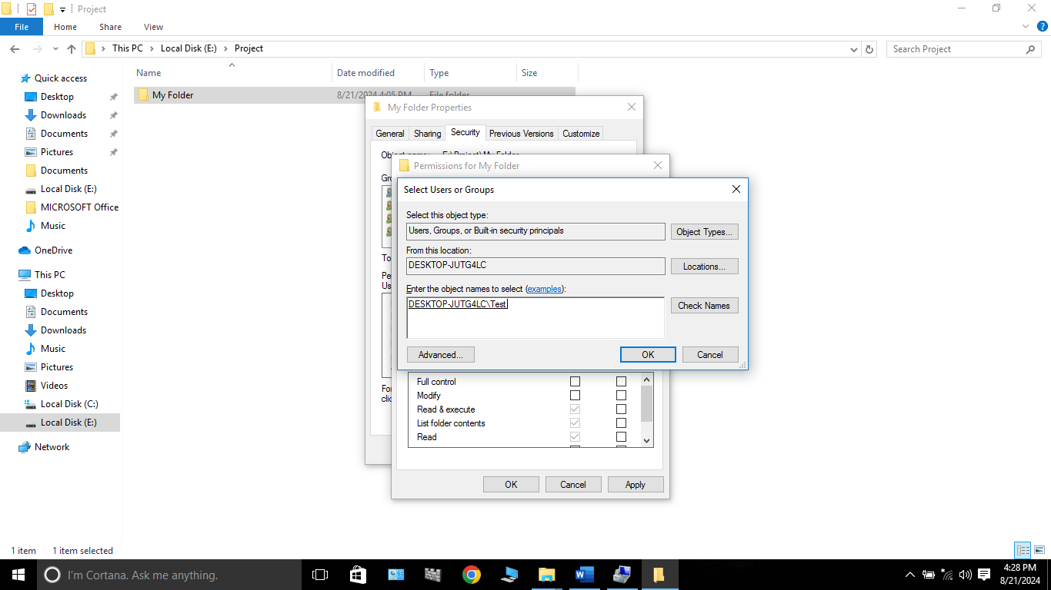

Step 4: Now I am changing the Folder permission by selecting ‘Test’ user and clicking on ‘Edit’ and changing ‘Read & Execute’ option into Deny. And clicking on ‘Apply’ and ‘ok’. Now ‘My Folder’ permission has been changed for ‘Test’ user.

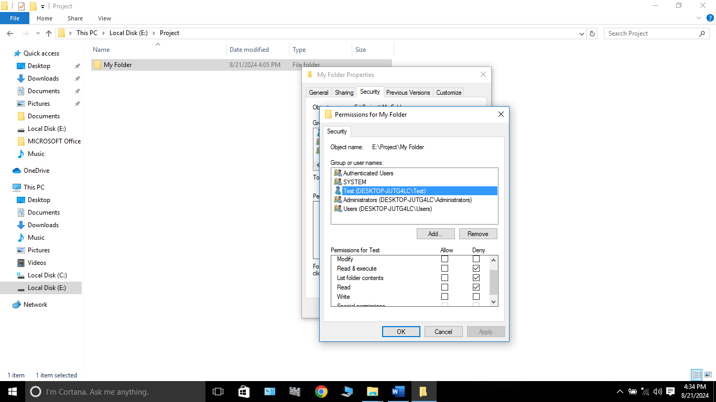

Step 5: Next I have to log in into ‘Test’ user account. So first I have click on ‘Start’ menu then click on my current user’s name which is ‘Atandra’ and there I get the list of the other users of my computer, and from there I have to choose ‘Test’ user.

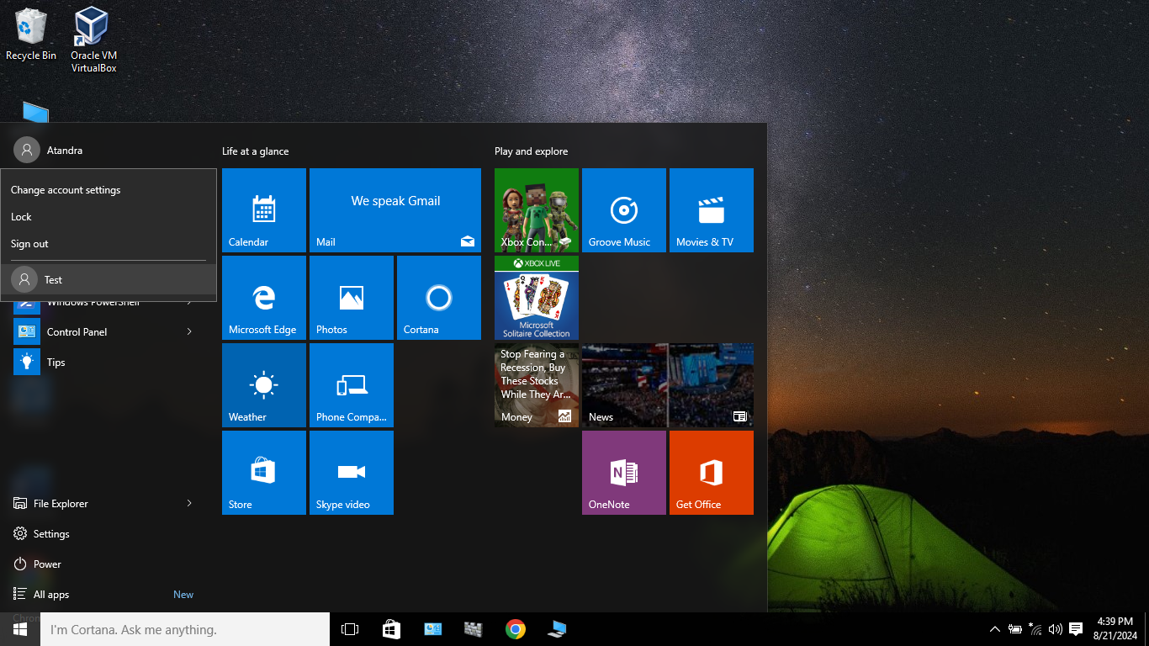

Step 6: Now I have logged into ‘Test’ user account. And after navigated to ‘My Folder’ location, I am encountering an error message here when I am trying to access ‘My Folder’ because my Execute permission is denied from Administrator user.

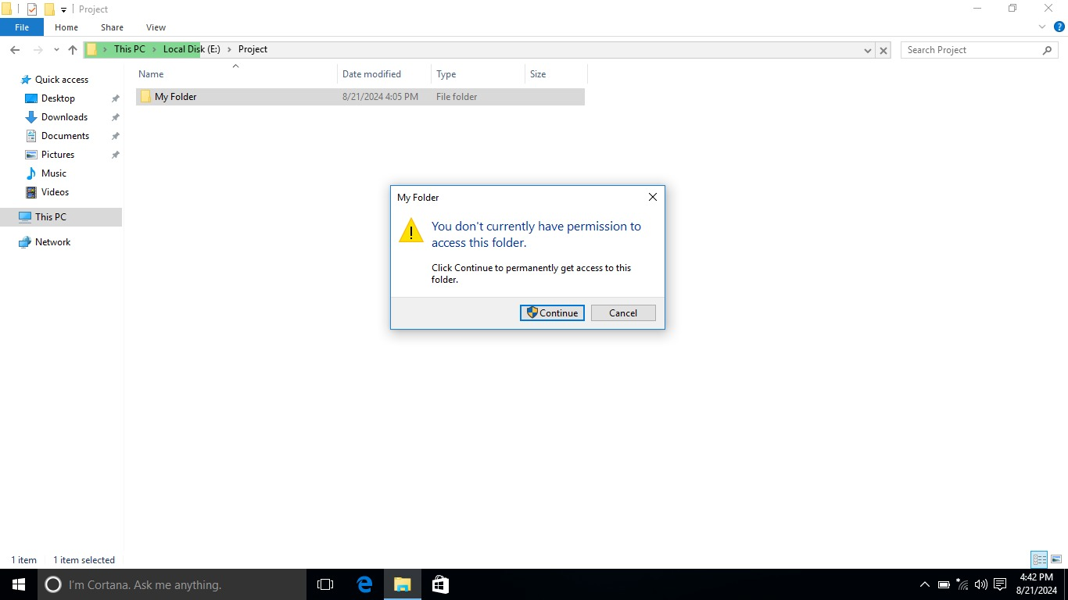

**Conclusion:**

This project has provided a comprehensive guide to changing permission of a folder for a user in Windows. By following the steps, you can create a new user and also you can change any folder permission.

This knowledge is important for IT professionals to manage their folder permissions for different users to prevent unauthorized access & accidental modifications of the folder, to maintain confidentiality of the folder.